These houseplants don’t just survive, they thrive!

Come in out of the chilly winter weather and explore what we have to offer for indoor gardening at our 2018 Houseplant Sale, January 11-24. Here are just a few of our favorite hassle free houseplants:

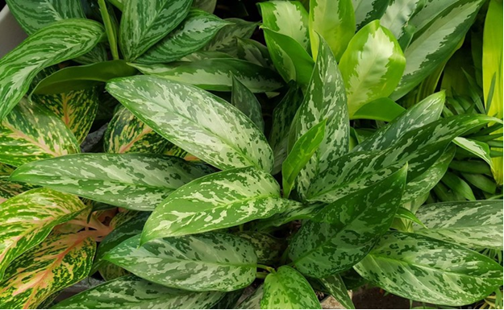Aglonema – Chinese Evergreen

An excellent foliage plant suitable for both low light and bright indirect light situations. It is a great air-purifier, slow growing, requires very little watering (let dry between watering) and likes to be root-bound. Its leaves are typically wide and long, slightly oval and come to a point. Each variety is variable in shape, size, color, and pattern.

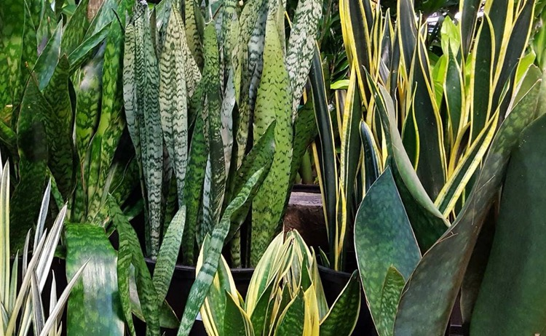

Sanseveria – Snake Plant, Mother-in-Law tongue

This classic houseplant is the easiest of all easy plants. It is most often selected because of its ability to adapt to dismally dark, cold, drafty and dry conditions, with a bit more love the Sansevieria is really a thing of beauty. With medium light levels and proper soil, the intricate bandings and variegations become far more pronounced and the leaves will be thick and full of vitality. With just a tiny bit of care, Sansevierias produce offsets freely via stout underground rhizomes. These baby plants can then be left in the same pot or detached and shared with friends! Occasionally, you may even be rewarded with a tall and dainty sweet-smelling flower stalk in light pink or white.

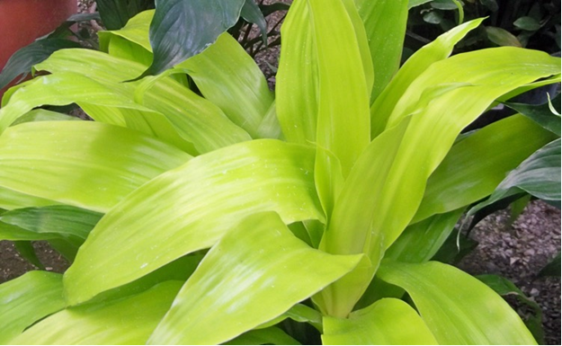Dracaena – Cane Palms

Commonly called Dragon Tree or Corn Plant, *Dracaena* like 65-75 degree temperatures in low light. Water thoroughly when the top 2" of soil becomes dry to the touch. Use a foliage fertilizer as directed on the product label. Dracaena take well to haircuts if they get too big. You can most likely root what you cut off by letting the cutting dry for a couple days to heal over; then use rooting hormone and rooting media.

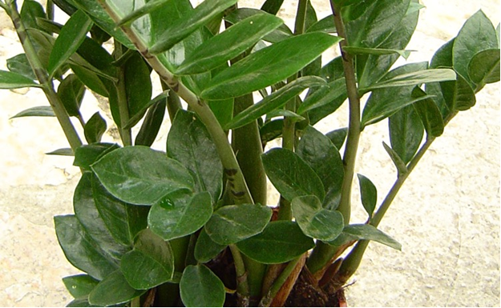Zamioculcas Zamifolia – Cardboard Plant

ZZ plant, short for Zamioculcas zamiifolia, is a stylish upright plant with thick arcing stems of dark glossy leaves. Like the snake plant—also ever popular for its ease of care—zz plants are suitable in low light situations and can go long periods in between watering. They are perfect for greening up areas of the house where there is dim window light. They perform well on a once-a-month watering regime.

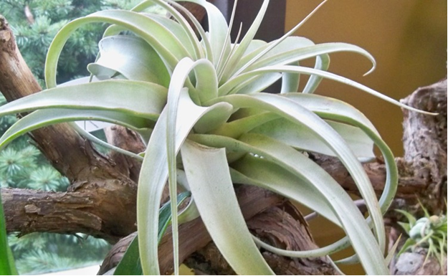Tillandsia – Air Plant

A beautiful airplant species native to the southern Mexico, where they grow in tree canopies and on rocks. Wide curly leaves of the silver Tillandsia xerographica whirl into a sculptural rosette and serve as a perfect focal point in a well-lit room. Their blooms are short and red with purple tubular petals. They flourish in bright indirect light, appreciate good air circulation and a weekly soak in water. They take most of their nutrients through the leaf system and bloom only once in their lifetime. Each plant should produce between 2 and 8 pups, each bloom within a year of emerging.